Sensing traffic mobility in the Washington D.C. area in 2011-2012 with the Bike Rental Data from the Capital Bikeshare system

Method: The casual, registered and overall bike rental counts were plotted as time series.
- From the daily bike rental count plots the peak traffic days are identified.
- The different patterns in the bike rental counts on the working days vs. on the non-working days are compared.
- 23rd March 2012 had the highest bike rental counts among the working days, whereas 15th September 2012 had the highest bike rental counts among the non-working days.
- The hourly bike rentals are plotted for both the above 2 days (which seem to be the most eventful days in the weekday & weekend resp.) and they have different patterns.

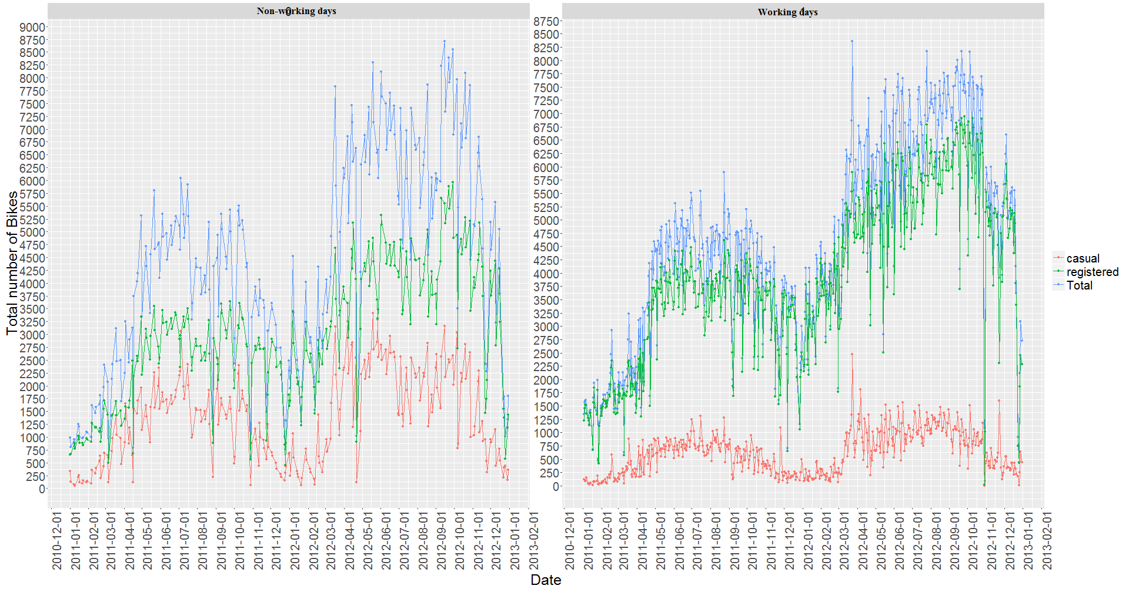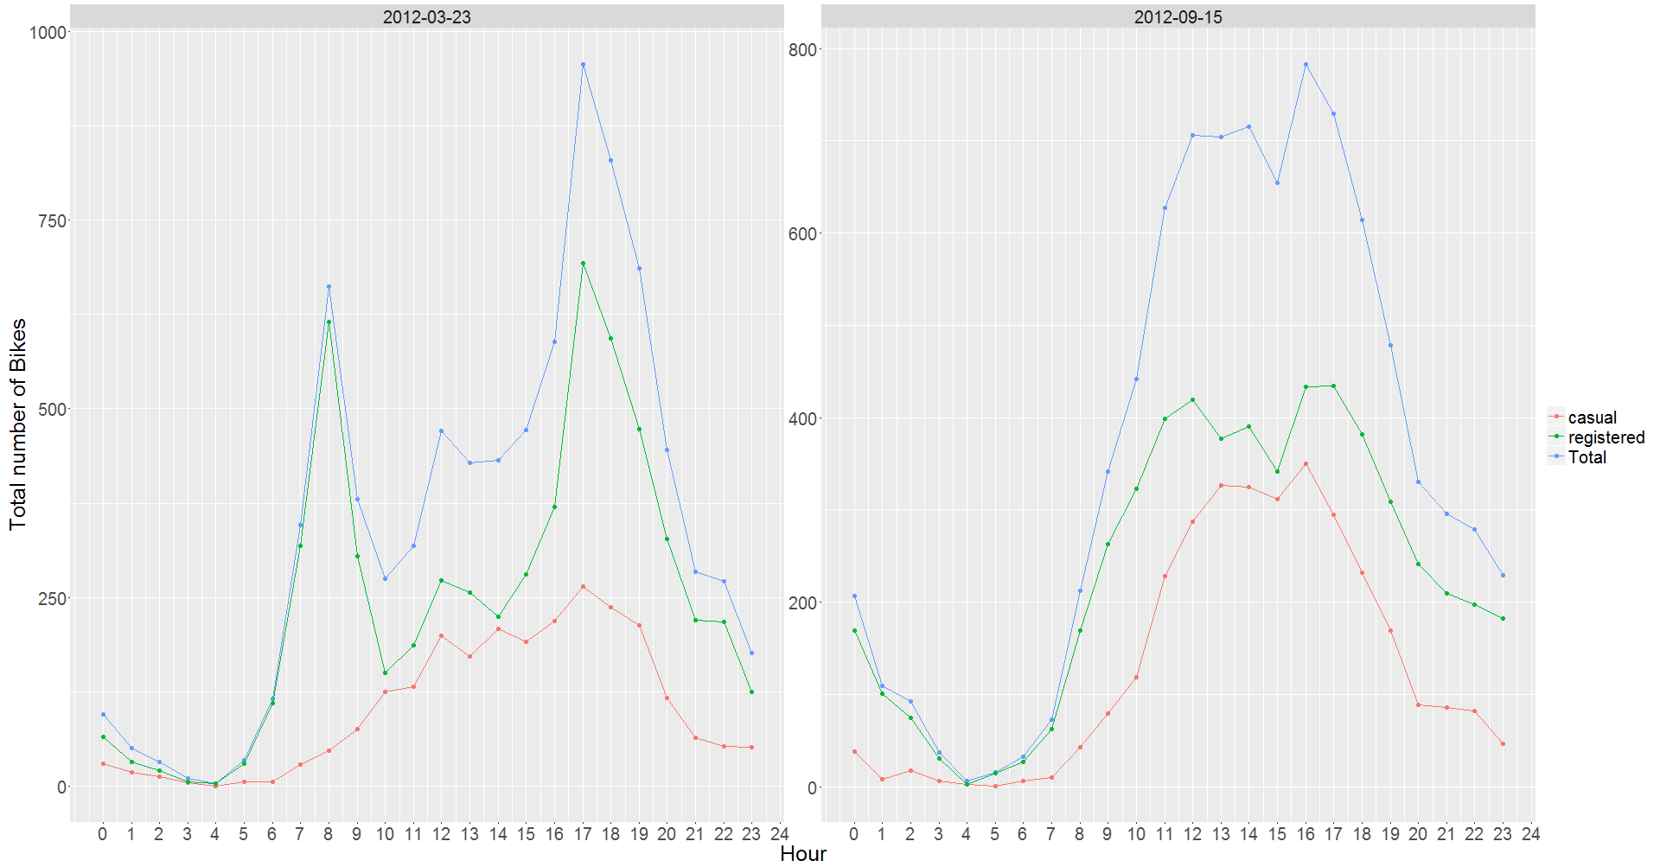
Conclusion
The most of important events in the city can be detected via monitoring the bike rental counts. At the same time, the number of bike-rental patterns in the working and in the non-working days can be seen to be quite different, as shown in the above figures.
Being a non-working day (Saturday) number bike rentals remains
pretty high throughout
the daytime till the
afternoon.
Being a working day (Friday) number of bike rentals has couple of peaks,
one in the morning and the other
in the evening.
Number of bike rentals reaches its maximum value in the mid of each year
Casual bike rental in non-working days is much higher on average than in working days

